MINERAL RESOURCES TASMANIA

Laboratory Report
LJN2021-033

XRD ANALYSES

Savage River Mine

An unpublished Mineral Resources Tasmania Report for:

R Bottrill

By: R S Bottrill,
L Unwin
Date: 22nd April 2021


Mineral Resources Tasmania
Department of State Growth

Summary

Summary
The results indicate one sample is a chlorite- mica amphibolite or schist, with potential for fibrous/asbestiform amphiboles, though no asbestos could be seen. One sample is a pink banded calcite-amphibole marble. The other two are both dominantly plagioclase and probably are albitites, with Kspar, amphibole and clinopyroxene; the gypsum and anhydrite identified by the HyLogger are unconfirmed.

Introduction
The Hylogger IR spectroscopic analyses of drill core, conducted by various Geological Surveys in Australia, routinely returns analyses indicating various minerals that often cannot be readily confirmed in the hand specimens, and require XRD (X-ray diffraction) or other methods for confirmation.

The objective of this study was to confirm the mineralogy of 4 samples of drill core from the Savage River Centre Pit deposit, Tasmania, by XRD, in order to validate the results from Hylogger analyses. In particular we wanted to identify any anhydrite, amphiboles and potential asbestos.

The sample details are given in Table 1.

Table 1: Sample details
Reg. # |  | Field No. | Location | Sample Description | Process
G407593 | CDDH13012 250.5m |  | Savage River | amphibolite? | xrd
G409726 | CDDH13012 229.9m |  | Savage River | anhydrite-albite? | xrd
G409727 | CDDH13012 231m |  | Savage River | anhydrite-albite? | xrd
G409728 | CDDH13012 238.7m |  | Savage River | anhydrite-albite? | xrd

Methodology
The samples were split into representative subsamples and analysed for mineralogy by XRD (X-Ray Diffraction) in the Mineral Resources Tasmania (MRT) laboratories, Rosny, and reported here.

Description
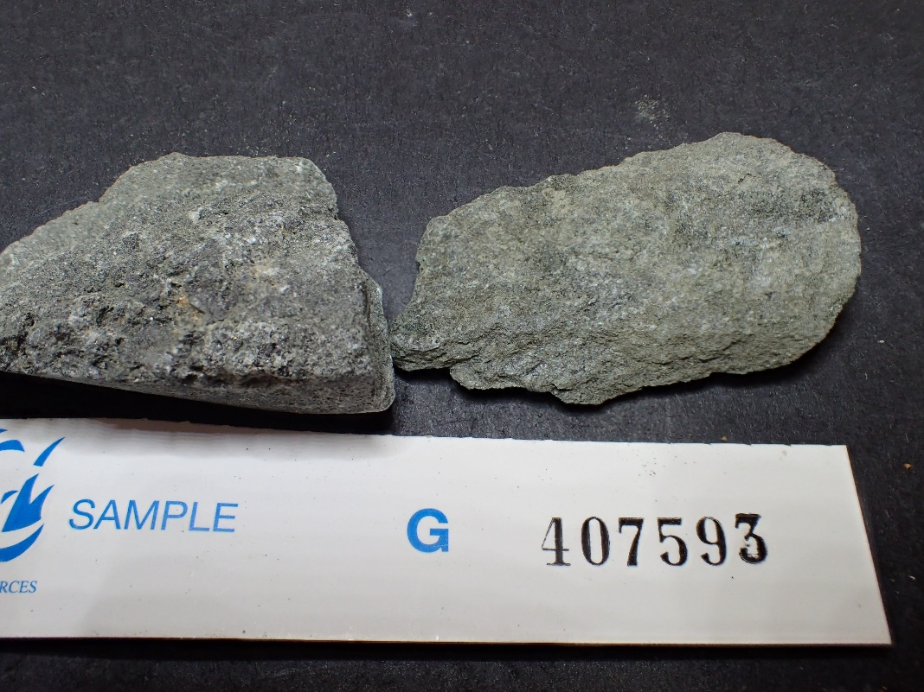
G407593 CDDH13012 250.5m Savage River chlorite-amphibole-mica schist
Figure 1. Sample G407593: strongly foliated chlorite-amphibole-mica schist. FOV ~85mm.

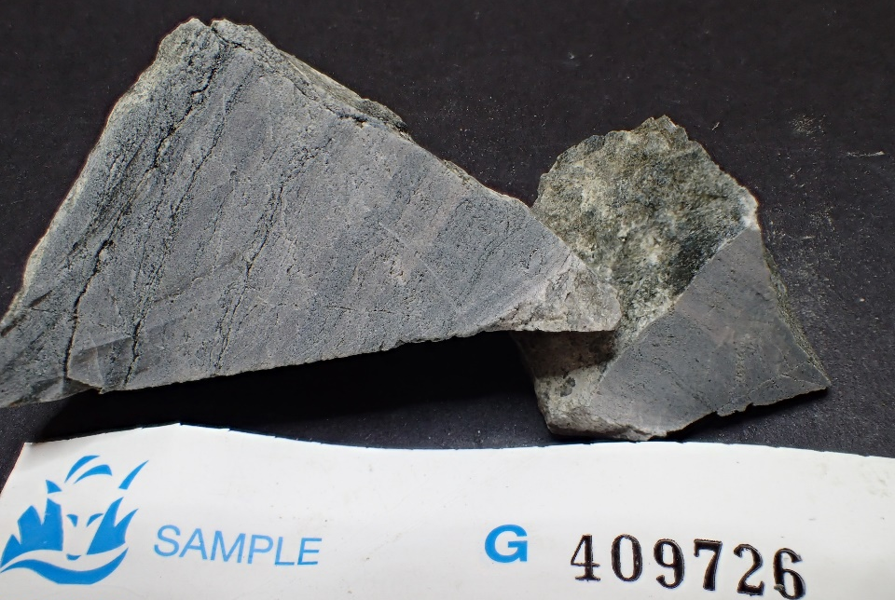
G409726 CDDH13012 229.9m Savage River albitite

Figure 2. Sample G409726: banded feldspathic metamafic rock, with green amphibole bands. FOV ~85mm.

G409727 CDDH13012 231m Savage River amphibole marble
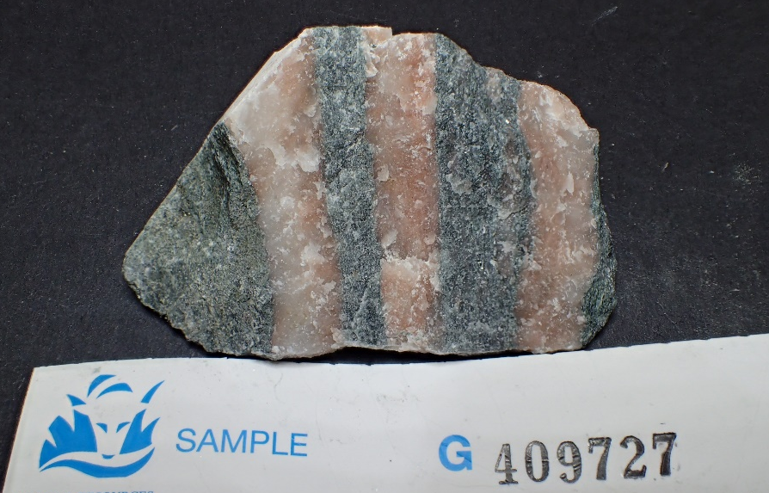
Figure 3. Sample G409727: strongly banded marble, with pink calcite and green amphibole bands. FOV ~85mm.

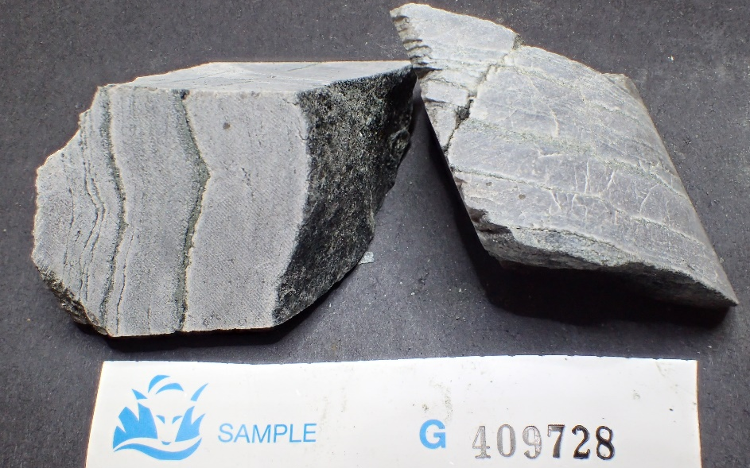
G409728 CDDH13012 238.7m Savage River pyroxene-albitite

Figure 4. Sample G409728: strongly laminated albitite, with green pyroxene bands. FOV ~85mm.

XRD analyses
The samples were prepared, examined, and analysed in the MRT laboratories, Rosny Park, Tasmania. They were run on a Rigaku Miniflex 600 X-Ray Diffractometer system: a 600W generator 150mm goniometer with a Cu tube; 40kV/15mA, sample spinner and a Scintillation counter (SC) with Be window, 3º to 63 º 2Theta scanning range, with a scanning speed of 0.5°/min, a graphite monochromator and a Kß Ni- filter. The analysis software used is the PDXL2 using the ICCD database.
Quantification is largely manual, using a series of prepared standards of the more common minerals to enable some semi-quantitative analysis. Quartz, if present, is used as an internal standard; and if not present, it is often added to the sample for a supplementary scan. Our semi-quantitative results are calculated using single-peak calibration factors derived from scans of known mixtures of minerals.
The results are shown in Appendix 1 and summarised in Table 2, with a comparison with the Hylogger results.

Table 2: XRD Results Summary (wt%)
Reg. # | Hole Number & Depth | Sample Description - Visual | General Hylogger -TIR Mineralogy. Highlighted cells are very possibly invalid. | XRD – Minerals >10%
G407593 | CDDH13012 250.5m | amphibolite? | Albite, gypsum, calcite, chlorite, talc, actinolite | Chlorite  Amphibole  Phengite
G409726 | CDDH13012 229.9m | anhydrite-albite? | Albite, gypsum, calcite, anhydrite | Plagioclase*  Kspar
G409727 | CDDH13012 231m | anhydrite-albite? | Albite, calcite, quartz, chlorite, anhydrite | Calcite
G409728 | CDDH13012 238.7m | anhydrite-albite? | Albite, calcite, quartz, anhydrite | Plagioclase*
* Probably albite.

Discussion and Conclusions
The results indicate G407593 is an amphibole-bearing chlorite-mica schist, with potential for fibrous/asbestiform amphiboles, though no asbestos could be seen. G409726 and G409728 are both dominantly plagioclase and probably are albitites; they also contain minor amphiboles. G409727 is a pink marble band, composed mostly of calcite. As in most previous reports, the gypsum and anhydrite identified by the HyLogger are unconfirmed.

R.S. Bottrill L Unwin

Mineralogist/Petrologist TECHNICAL OFFICER

Disclaimers:
While every care has been taken in the preparation of this report, no warranty is given as to the correctness of the information and no liability is accepted for any statement or opinion or for any error or omission. No reader should act or fail to act on the basis of any material contained herein. Readers should consult professional advisers. As a result the Crown in Right of the State of Tasmania and its employees, contractors and agents expressly disclaim all and any liability (including all liability from or attributable to any negligent or wrongful act or omission) to any persons whatsoever in respect of anything done or omitted to be done by any such person in reliance whether in whole or in part upon any of the material in this report. The MRT laboratories are not NATA registered but work to similar standards. This and other data collected in MRT laboratories may enter the MRT databases but every attempt will be made to ensure it remains closed file and not be available externally, unless at your request.
Appendix 1: MRT Laboratory Report

Lab Job No.: LJN2021-033
Submitted by: R Bottrill
Analysis type: XRD
Date completed: 15/04/2021
Analyst: L Unwin
MRT Laboratory Manager: Ralph Bottril

XRD Results-G409728-LJN2021-033-Savage River-QA1-15/4/2021

General Information

Measurement date: | 15/04/2021 | Interpretative date: | 15/04/2021
Job Number/Client: | LJN2021-033 Savage River | XRD | Rigaku Miniflex 600
Registration Number: | G409728 | Analyst: | LUnwin
Quantitative Method: | PDXL Relative Heights | Process Medium: | Wholerock
Sample Holder: | Standard | Speed (deg/min): | 0.5
Comments: | Shifted -0.03

Analysis Results

Phase name | Content wt% (± error) | Formula
Quartz | 2(2) | SiO₂
Plagioclase* | 86(10) | NaAlSi₃O₈
Chlorite* | 1(1) | (Mg,Fe,Al)₆(Si,Al)₄O₁₀(OH,O)₈
Calcite | 1(1) | CaCO₃
Phlogopite* | <1 | KMg3Fe3+Si3O10(OH)2
Titanite | <1 | Ca(TiO)(SiO₄)
Amphibole* | <1 | Ca₂(Mg₄Al)(Si₇AlO₂₂)(OH)₂
Clinopyroxene* | 9(3) | (Ca,Na)(Mg,Fe,Al)Si₂O₆

Notes
Peak overlap may interfere with identifications and quantitative calculations.
Amorphous minerals and minerals present in trace amounts may not be detected.
Plagioclase* probably Albite
Chlorite* probably Clinochlore
Amphibole* possibly Magnesio-hornblende
Clinopyroxene* probably Augite
Phlogopite* possibly Fe-rich Phlogopite

Phase Data Pattern

XRD Results-G407593-LJN2021-033-Savage River-QA1-16/4/21

General Information

Measurement date: | 15/4/2021 | Interpretative date: | 16/4/2021
Job Number/Client: | LJN2021-033 Savage River | XRD | Rigaku Miniflex 600
Registration Number: | G407593 | Analyst: | LUnwin
Quantitative Method: | PDXL Relative Heights | Process Medium: | Wholerock
Sample Holder: | Standard | Speed (deg/min): | 0.5
Comment: | Shifted -0.07

Analysis Results

Phase name | Content wt% (± error) | Formula
Quartz | 2(2) | SiO₂
Magnetite | 9(3) | Fe²⁺Fe³⁺₂O₄
Chlorite* | 41(10) | (Fe,Mg,Al)₆(Si,Al)₄O₁₀(OH)₈
Amphibole* | 22(5) | Ca₂(Mg₄Al)(Si₇AlO₂₂)(OH)₂
Plagioclase* | 1(1) | NaAlSi₃O₈
K-Feldspar* | 2(2) | (K,Na)AlSi₃O₈
Biotite | <1 | Mg(OH)₂
Phengite | 22(5) | K_{0.98}Na_{0.02}Mg_{0.24}Ti_{0.02}Fe_{0.21}Al_{2.18}Si_{3.37}O₁₀(OH)²
Calcite | <1 | CaCO₃

Notes
Peak overlap may interfere with identifications and quantitative calculations.
Amorphous minerals and minerals present in trace amounts may not be detected.
Amphibole* possibly Magnesio-hornblende
Chlorite* probably Mg-rich Chamosite
Plagioclase* probably Albite
K-Feldspar* probably Microcline

Phase Data Pattern

XRD Results-G409727-LJN2021-033-Savage River-QA1-15/04/2021

General Information

Measurement date: | 15/04/2021 | Interpretative date: | 15/04/2021
Job Number/Client: | LJN2021-033 Savage River | XRD | Rigaku Miniflex 600
Registration Number: | G409727 | Analyst: | LUnwin
Quantitative Method: | PDXL Relative Heights | Process Medium: | Selective pink layer
Sample Holder: | Standard | Speed (deg/min): | 0.5
Comment: | Shifted -0.03

Analysis Results

Phase name | Content wt% (± error) | Formula
Quartz | 2(2) | SiO₂
Plagioclase* | 2(2) | NaAlSi₃O₈
Calcite | 89(10) | CaCO₃
Amphibole* | 5(3) | Ca₂(Mg₄Al)(Si₇AlO₂₂)(OH)₂
Illite | 2(2) | K_{0.7}Al₂[Al_{0.7}Si_{3.3}O₁₀](OH)₂

Notes
Peak overlap may interfere with identifications and quantitative calculations.
Amorphous minerals and minerals present in trace amounts may not be detected.
Plagioclase* probably Albite
Amphibole* possibly Magnesio-hornblende

Phase Data Pattern

XRD Results-G409726-LJN2021-033-Savage River-QA1-15/4/2021

General Information

Measurement date: | 15/4/2021 | Interpretative date: | 15/4/2021
Job Number/Client: | LJN2021-033 Savage River | XRD | Rigaku Miniflex 600
Registration Number: | G409726 | Analyst: | LUnwin
Quantitative Method: | PDXL Relative Heights | Process Medium: | Wholerock
Sample Holder: | Standard | Speed (deg/min): | 0.5
Comment: | Shifted -0.05

Analysis Results

Phase name | Content wt% (± error) | Formula
Quartz | 3(2) | SiO₂
Plagioclase* | 73(10) | NaAlSi₃O₈
Amphibole* | 3(2) | Ca₂(Mg₄Al)(Si₇AlO₂₂)(OH)₂
Chlorite* | 1(1) | (Mg,Fe,Al)₆(Si,Al)₄O₁₀(OH,O)₈
Biotite | <1 | K(Mg,Fe)₃[AlSi₃O₁₀](OH)₂
Calcite | 1(1) | CaCO₃
Clinopyroxene* | 6(3) | (Ca,Na)(Mg,Fe,Al)Si₂O₆
Anhydrite | 1(1) | CaSO₄
K-Feldspar* | 12(4) | K(AlSi₃O₈)

Notes
Peak overlap may interfere with identifications and quantitative calculations.
Amorphous minerals and minerals present in trace amounts may not be detected.
Plagioclase* probably Albite
Amphibole* possibly Magnesio-hornblende
Chlorite* probably Clinochlore
Clinopyroxene* probably Augite
K-Feldspar* probably Orthoclase

Phase Data Pattern

