Laboratory Report

LJN2020-038

Mineralogical / asbestos analyses, Brassey South

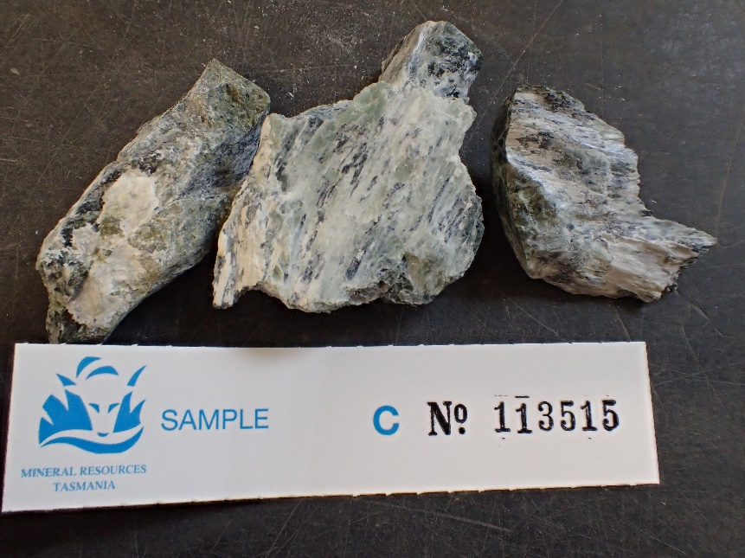
An unpublished Mineral Resources Tasmania Report

For S. Newett, MRT

By: R S Bottrill

Date: 22/04/2021
By: R.S. Bottrill and L Unwin
Date: 22 April 2021

Summary
Drillcore from Brassey South, Heazlewood, was sampled and analysed to check for potential asbestos. Petrological and XRD investigation revealed the fibrous veins contained mostly hydromagnesite with lizardite and trace pyroaurite and brucite with very little or no asbestiform component.

Introduction

Drillcore from Brassey South (ID #92115) drillhole near Heazlewood, NW Tasmania, appeared to contain abundant veins of fibrous white material, potentially asbestos, so it was sampled and analysed to mineralogically check for asbestos, with its details shown in Table 1 & 2.

Table 1: Sample Details
Reg. No | Drillhole details | Location | Process | Description
C113515 | BS001 (ID#92115), 14.8m | Brassey | XRD, PL Microscopy | White fibrous veins in serpentine

Sample description

The sample is mostly mid to dark green massive serpentine with abundant friable and roughly fibrous white veins, from <1 mm to a few cm thick (Fig. 1). No asbestiform fibre could be seen.

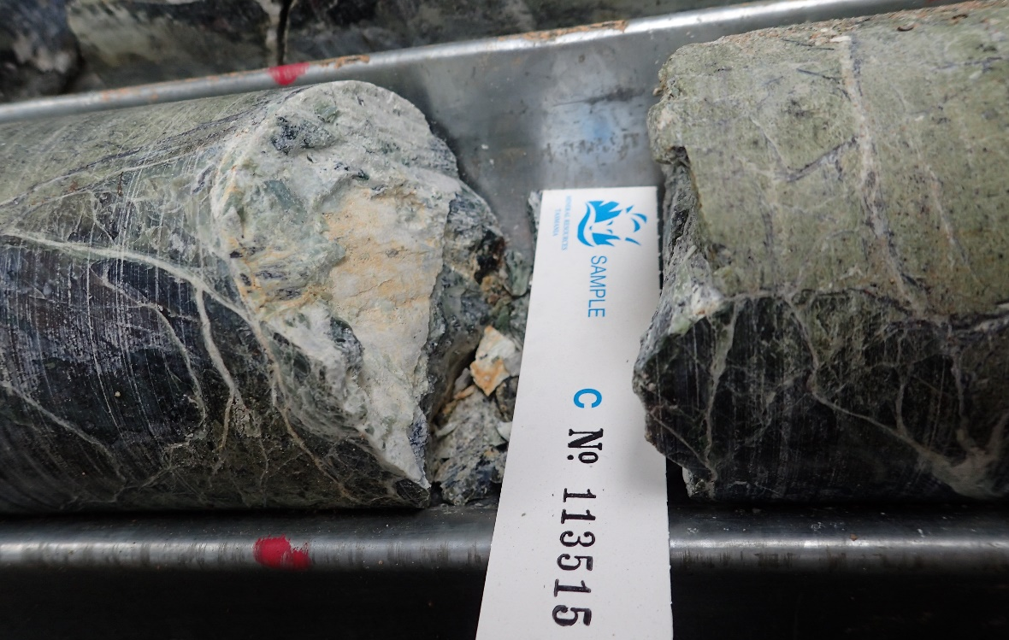
Figure 1, C113515. White fibrous veins in serpentine. FOV ~120mm.

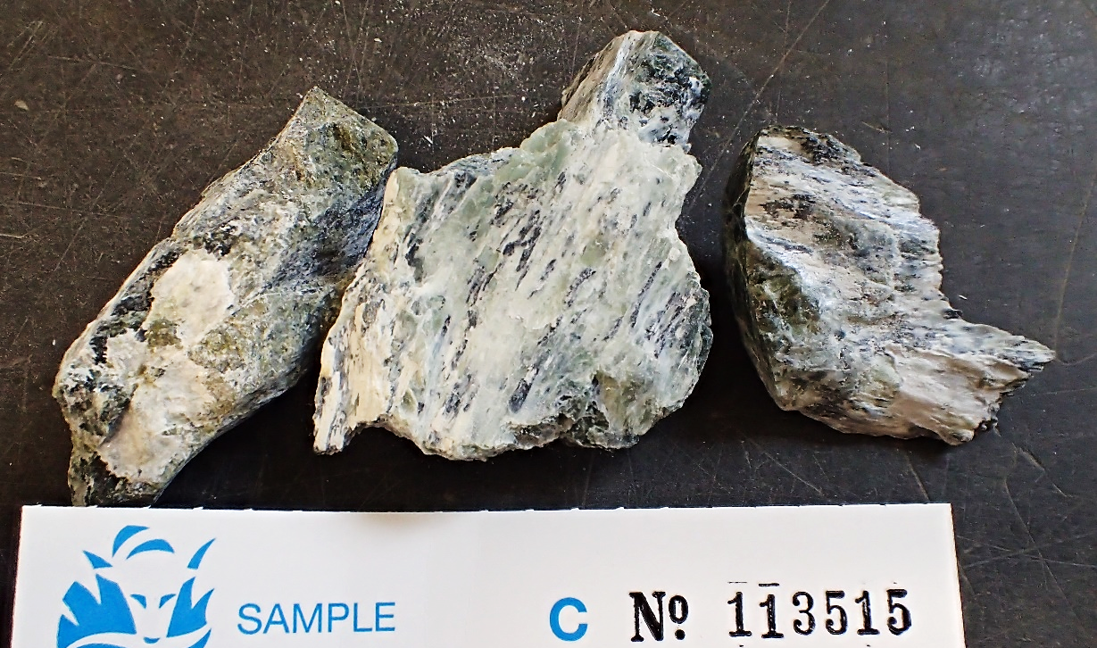
Figure 2. C113515. White fibrous veins in serpentine. FOV ~120mm.

XRD analyses

The samples were prepared, examined and analysed in the MRT laboratories, Rosny Park, Tasmania. They were run on a Rigaku Miniflex 600 X-Ray Diffractometer system: a 600W generator 150mm goniometer with a Cu tube; 40kV/15mA, sample spinner and a Scintillation counter (SC) with Be window, -3º to 145º 2Ø scanning range and 3º - 145º 2Ø measuring range, with a scanning speed of 0.01 to 100º/min, a graphite counter monochromator and a Kß Ni- filter. The analysis software used is the PDXL2 using the ICCD database.
Quantification is largely manual, using a series of prepared standards of the more common minerals to enable some semi-quantitative analysis. Quartz, if present, is used as an internal standard; and if not present, it is often added to the sample for a supplementary scan. Our semi-quantitative results are calculated using single-peak calibration factors derived from scans of known mixtures of minerals.
The results are shown in Appendix 1 and Table 1.

Table 1: Sample Details
Phase name | Approx. content
Hydromagnesite | Dominant
Lizardite | Sub-major
Pyroaurite | Trace
Brucite | Trace

Fibre examination

The samples were prepared and examined by low to high power plain and polarised light microscopy in the MRT laboratories, Rosny Park, Tasmania. This examination revealed that it contains some coarse fibre but very little or no asbestiform fibrous material.

Table 2: Microscopic Examination

Reg. No. | Location | Observation
C113515 | Brassey South | No asbestos fibres

Conclusions and Discussion

There was no asbestiform material found in this sample. The fibrous white veins consist mostly of hydromagnesite with trace amounts of pyroaurite and brucite. The serpentine matrix appears to be mostly lizardite. The risk of asbestos with this material is considered very low.

R.S. Bottrill L Unwin

Mineralogist/Petrologist Technical Officer

Disclaimers
While every care has been taken in the preparation of this report, no warranty is given as to the correctness of the information and no liability is accepted for any statement or opinion or for any error or omission. No reader should act or fail to act on the basis of any material contained herein. Readers should consult professional advisers. As a result the Crown in Right of the State of Tasmania and its employees, contractors and agents expressly disclaim all and any liability (including all liability from or attributable to any negligent or wrongful act or omission) to any persons whatsoever in respect of anything done or omitted to be done by any such person in reliance whether in whole or in part upon any of the material in this report. The MRT laboratories are not NATA registered but work to similar standards.
This and other data collected in MRT laboratories may enter the MRT databases but every attempt will be made to ensure it remains closed file and not be available externally, unless at your request.

Appendix 1: MRT Laboratory Report

Client: MRT
Sample Location: Brassey South
Job Number: LJN2021-038
Analyses: Approximate Mineralogy
Methods: XRD
Analyst: L Unwin
Lab Manager: R Bottrill
Date: 16/04/2021

XRD Results-C113515

General Information

Measurement date: | 16/4/2021 | Interpretative date: | 16/4/2021
Job Number/Client: | LJN2021-038 OHS | XRD | Rigaku Miniflex 600
Registration Number: | C113515 | Analyst: | LUnwin
Quantitative Method: | Semi-quantitative | Process Medium: | Selective white material
Sample Holder: | Low Reflectance Holder | Speed (deg/min): | 0.5
Comment: | Shifted -0.15

Analysis Results

Phase name | Content - Estimate
Hydromagnesite | Dominant
Lizardite | Sub-major
Pyroaurite | Trace
Brucite | Trace

Notes
Peak overlap may interfere with identifications and quantitative calculations.
Amorphous minerals and minerals present in trace amounts may not be detected.

Phase Data Pattern

